DOWNLOAD THE SAFESPORT PARENT TOOLKITS HERE!

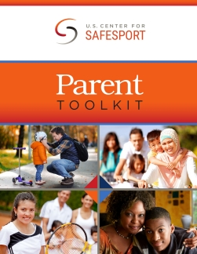

https://resources.safesport.org/toolkits/library.html

